ESOF 322 – Homework 1

Grant Baker, Jonah Gilbertson

September 9,2018

1. 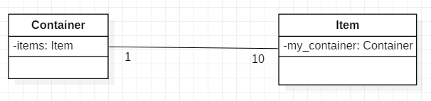
2. 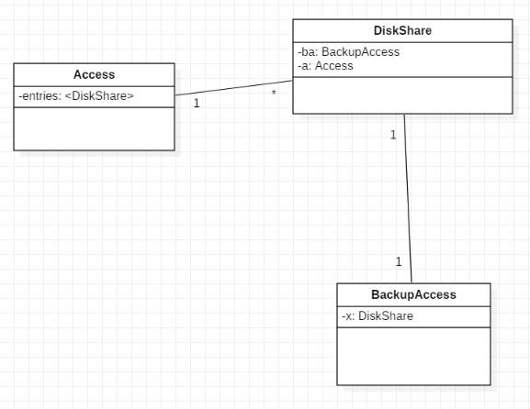

3.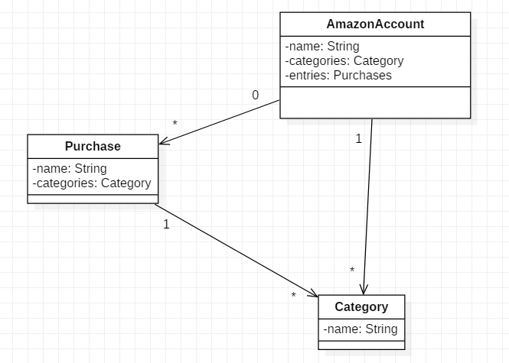

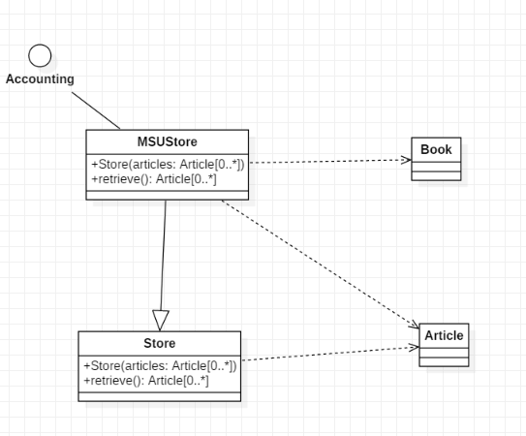4.

public class Service extends VehicleRentalService{

public Customer[1] customer;

}

public class VehicleRentalService{

public Vehicle[1] vehicle;

public offerCar(){}

public offerMotorbike(){}

public offerTruck(){}

}

public class Company{

public String[1] name;

public Address[1] heahdquarters;

public VehicleRentalService service;

public List<Motorbike> motorbike;

public List<Car> car;

public List<Truck> truck;

public List<Customer> customer;

public List<Employee> employee;

}

public class Motorbike extends Vehicle{

public MbKind[1] kind;

public UnlimitedNatural cylinderCap;

public UnlimitedNatural[1] power;

public String[1] manufacturer;

public String[1] regNo;

}

public class Car extends Vehicle{

public CarKind[1] kind;

public UnlimitedNatural noSeats;

public UnlimitedNatural[1] power;

public String[1] manufacturer;

public String[1] regNo;

}

public class Truck extends Vehicle{

public UnlimitedNatural[1] weight;

public UnlimitedNatural[1] power;

public String[1] manufacturer;

public String[1] regNo;

}

public class Vehicle implements Rentable{

}

interface Rentable{

public rent(){}

}

public class BankAccount{

public UnlimitedNatural[1] number;

public String[1] depositor;

public String[1] bank;

}

public class Customer extends Person{

public BankAccount bankAccount;

}

public class Subcontractor extends Customer, Employee{

}

Public class Employee extends Person{

}

public class Person{

public String[1] name;

public String[1] email;

public Address address;

}

public class Address{

public String[1] street;

public String[1] postalCode;

public String[1] city;

}